Title:Design and Implementation of an AI-Based Student Support Assistant using Google Dialogflow
- Aim
To design and implement an AI-based Student Support Assistant using Google Dialogflow that provides instant responses to student queries related to fee payment, scholarships, examination results, faculty contact, and placement services.
- Problem Analysis and Agent Design
The university receives a large number of student queries every day regarding fee payment, scholarships, examination results, faculty contact, and placement services. Responding to these queries manually takes time and increases the workload of university staff. Students may also experience delays in getting accurate information, especially outside office hours. Therefore, an AI-based Student Support Assistant is required to provide instant, accurate, and 24/7 responses to student queries.
Why Artificial Intelligence?
Artificial Intelligence enables chatbots to understand natural language, identify user intentions, and provide relevant responses automatically. An AI-based chatbot can answer multiple student queries simultaneously, reduce the workload of university staff, improve response speed, and provide consistent information at any time. By using Dialogflow, the chatbot recognizes user intents and entities, making interactions more intelligent and user-friendly.
- Dialogflow Agent Development
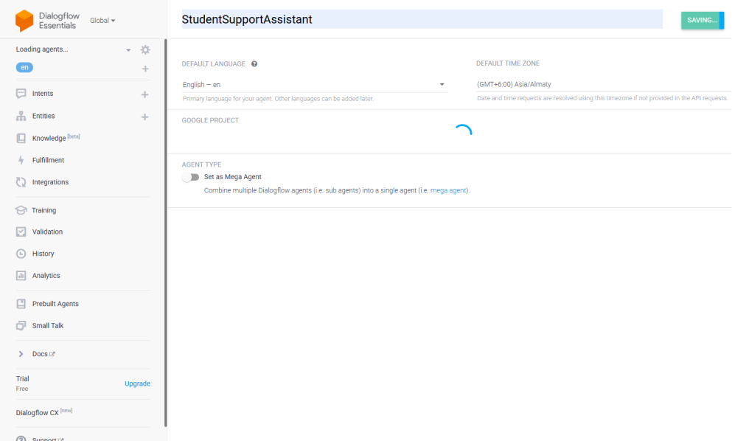
Step 1:Created Dialogflow Agent

Step 2:Created Intents
- Fee_Payment
- Scholarship_type
- Results
- Faculty_Contact
- Placement_Cell
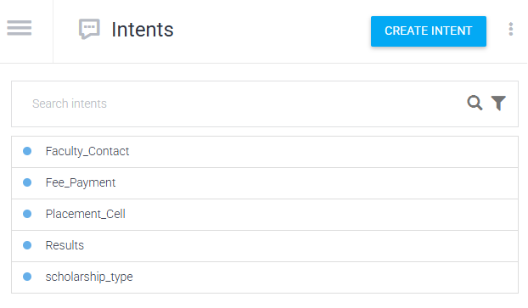

Step 3:Created Entities
Entity | Values
fee_type | Tuition, Hostel, Examination, Transport
scholarship_type | Merit, Sports, Minority
result_type | Semester, Mid, Final
department | CSE, AI, ECE, EEE
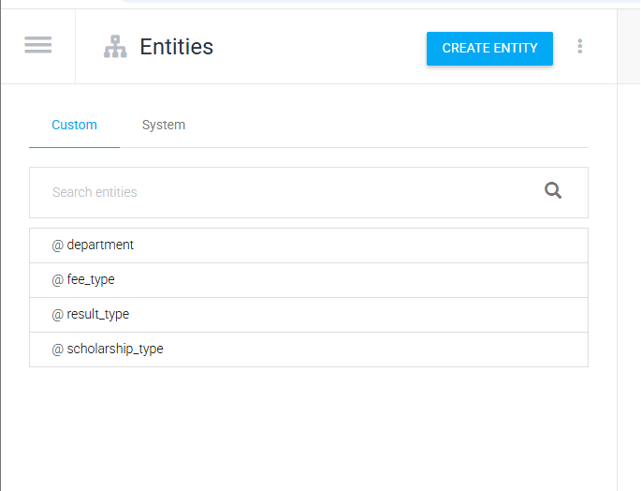

Step 4:Linked Entities to Intents
Example:
Training Phrase : I want to pay tuition fee
Highlighted: tuition fee
Entity: @fee_type
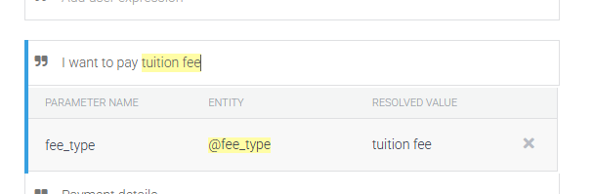

Step 5:Responses
Add reponses
Choose one intent (for example, Fee_Payment) and show its response.
Example Response (Fee_Payment):
You can pay your semester fees through the University Student Portal.
Steps:
- Login to the Student Portal.
- Select Fee Payment.
- Choose the semester.
- Complete the payment before the deadline.
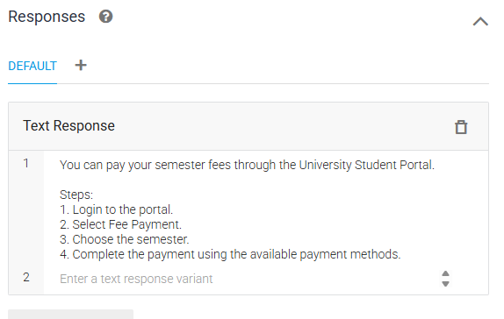

Step 6: Contexts
Intent | Output Context
Fee_Payment | fee_payment_context
Scholarship | scholarship_context
Results | result_context
Faculty_Contact | faculty_context
Placement_Cell | placement_context

Example 1: Fee_Payment Intent
Output Context : fee_payment_context
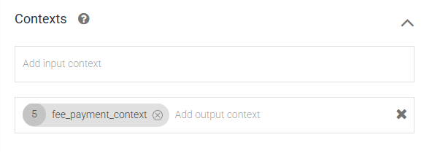
Lifespan: 5

4. Problem Formulation and Conversation Flow

Initial State : User opens chatbot.

Goal State : Student receives the required information.

Actions
- Ask fee details
- Ask scholarship
- Ask result
- Ask faculty contact
- Ask placement details
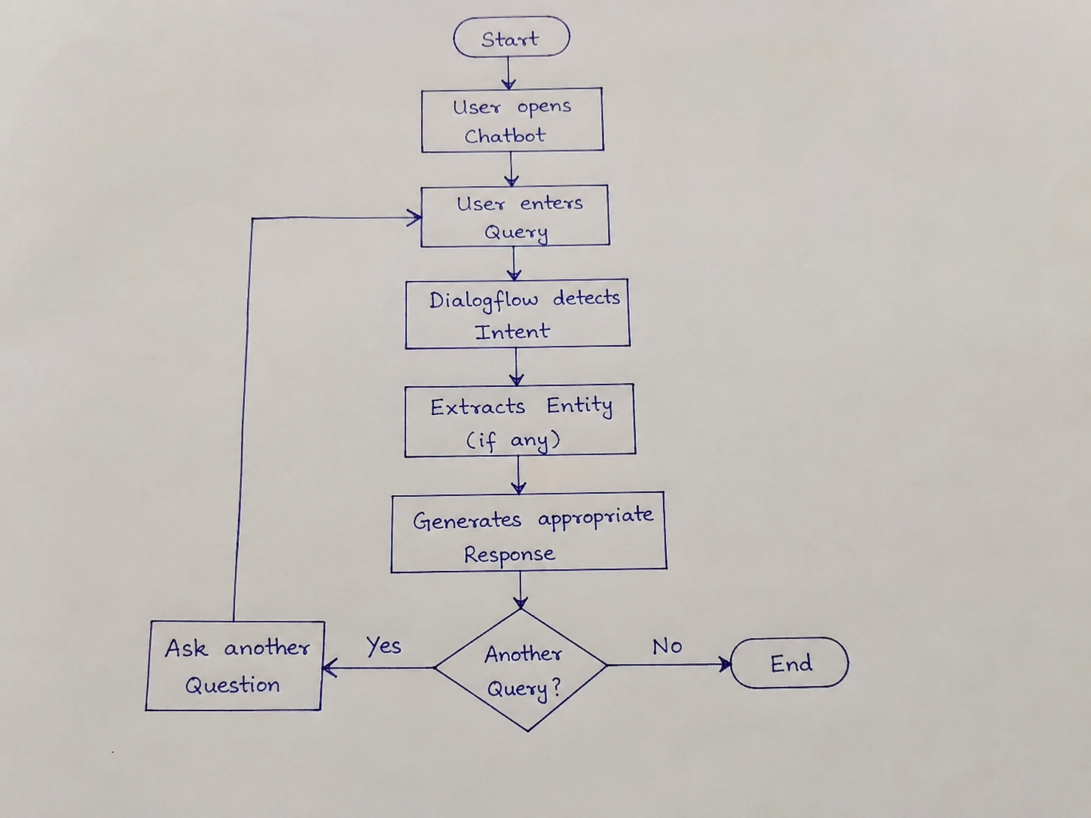

5. Search Strategy Application

Breadth First Search (BFS)
- User enters query.
- Dialogflow checks all intents.
- Finds the closest matching intent.
- Generates the correct response.
Why BFS?
- Easy navigation.
- Fast intent selection.
- Suitable for small chatbot.

6. Testing and Evaluation
Create a table.
Test Case | User Input | Expected Output | Result
1 | Hi | Welcome message | Pass
2 | Fee payment | Fee response | Pass
3 | Weather  \today | Default  fallback | Pass

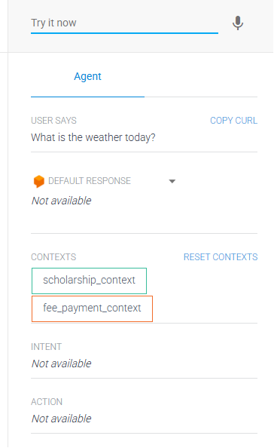
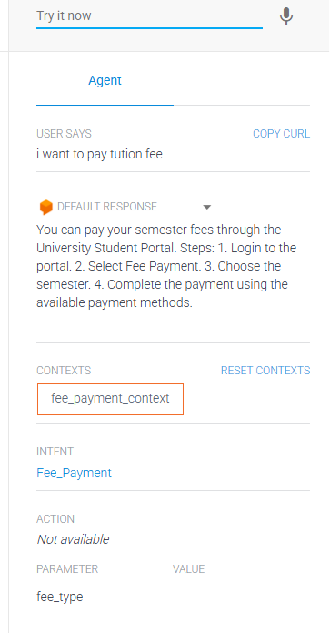

7. Conclusion
The AI-based Student Support Assistant was successfully implemented using Google Dialogflow. The chatbot correctly identified user intents, extracted entities, and provided accurate responses to student queries. The chatbot can be further enhanced by integrating it with the university database for real-time information.

